kentech
CONTROLS LLC

RIM-5
Remote Indication Module
Description
The RIM-5 is a five channel 24V Indication Module for use with a single RAM (optional audible alarm module) and multiple controls or alarm sensing devices. The RIM-5 contains five LED lamps on a standard size wallplate. When an alarm is initiated by a contact closure feeding 24V to one of the channels of the RIM-5, the corresponding LED is illuminated, and the 24V signal is passed on to the RAM for an audible indication. With a glance, the RIM-5 allows the user to visually determine which alarm has been initiated. Safe class 2 wiring allows easy remote mounting from the control location. The RIM-5 can be used to provide multiple point alarm indication for temperature, leak detection, pressure, flow, motion, humidity or any other sensing device that provides a contact closure. Up to five controls may be used with the RIM-5. A box next to each LED allows the user to label the application being monitored. Just write in a description with pen or marker and the user can quickly determine which area is in alarm when the LED is illuminated.
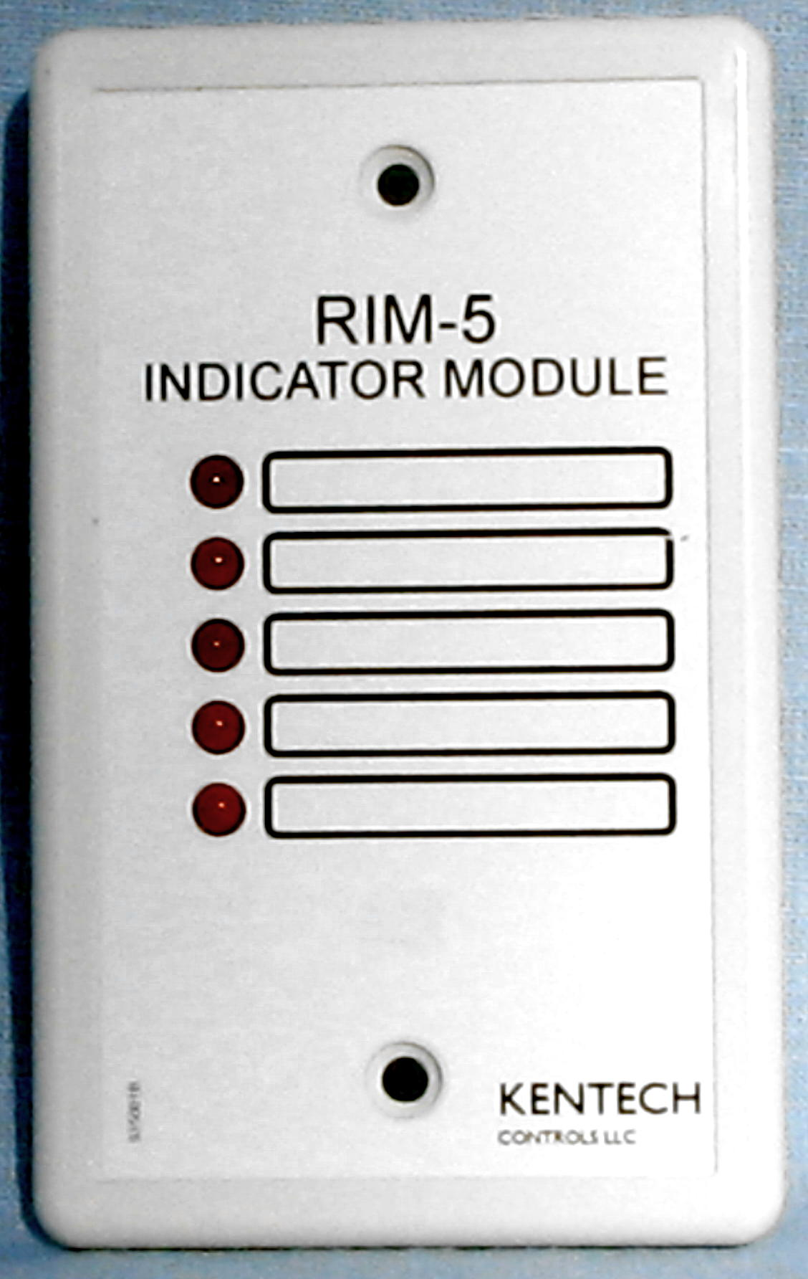
Specifications
Inputs: 5, 24V AC/DC +/-10%; 1.5VA
Output: 24V Halfwave dc to RAM
Operating Temperature: -30º to 130
Operating Humidity: 0-95% non-condensing
RoHS compliant MADE IN USA

Installation
The RIM-5 may be mounted in any location, at any distance from controls or alarm sensing devices that provide a contact closure of 24V. The module is designed to be mounted to a standard single gang electrical box with screws provided. The wiring diagram below shows the RIM-5 wired to five controls. If other alarm sensing devices or controls are to be used, wire similarly. Up to five devices can be wired in this manner. Screw terminals on the RIM-5 are provided for both input and output wiring
Input wiring
The large 10 position screw terminal block on the RIM-5 is used for input wiring from the output of controls or alarm sensing devices. Input voltage for the RIM-5 must be 24VAC or 24VDC. Even numbered screw terminals are not needed but can be used as additional wiring points for the "neutral" or "negative" legs. Odd numbered screw terminals are used for the "hot" or "positive" legs. The output of each control or alarm device should be wired to one of five consecutive odd screw terminals: 1,3,5,7 or 9. Each one of these has a corresponding LED which will light when there is input voltage. For example, if there is just one control/alarm device, wire to the input screw terminals labeled "1". When the control/alarm device output is on (24v to the RIM-5), the #1 LED (top) will light. NOTE: When using more than one control/alarm device, 24v from each device must be from the same source.
Output wiring
The small 3 position screw terminal block on the RIM-5 is used for output wiring to other alarm devices (horns, buzzers, lights, etc). Wire the "hot" or "positive" leg of the alarm device to the screw terminal labeled "1". Wire the "neutral" or "negative" leg of the alarm device to the screw terminal labeled "3". There is no connection at "2". When the RIM-5 receives 24v on any channel, it will output 24v (from the same source) to the alarm device wired to the output.

WIRING DIAGRAM SHOWING RIM-5 WITH OPTIONAL RAM MODULE
Operation
The RIM-5 may be used as an indication module control, or any other devices capable of making a contact closure of 24VAC. When an off temperature condition exists, the alarm device will make a contact closure which supplies the RIM-5 with 24V. The corresponding LED will illuminate as the RIM-5 passes the 24V on to a RAM or other device through the output terminals. If this condition returns to normal (alarm device opens contacts) the LED will go off and there will be no voltage at the red and white leads. Operation is very straightforward as there are no adjustments or settings on the RIM-5. A quick check can be performed on the RAM to verify that it is functioning properly. Apply 24V to the RIM-5 at any one of the five inputs. The corresponding LED should be on and there should be 24VDC half wave rectified at the output terminals.

WIRING DIAGRAM SHOWING MULTIPLE RIM-5 WITH OPTIONAL RAM MODULE

KENTECH CONTROLS LLC
10 Partridge Lane Toll Free 877-7KENTECH Huntington, NY 11743 Phone/Fax 877-753-6832 www.kentechcontrols.com
P/N 121202 1/11

